# # # # # # # # # # # # # # # # # # # # #

# Laboratory Exercise #

# Human-Computer Interaction #

# # # # # # # # # # # # # # # # # # # # #

**Principles that were satisfied by the designers and developers of the website:**

So basically, the designers and developers satisfied the following principles: Know the User, Understand the Task, and Strive for Consistency. Reason for me picking “Know the User” is because just by looking at the home page, the user won’t be confused as to how the UI works or how to get to this and that. Now for the reason for me picking ‘Understand the Task” is because the website knows what the user is doing, the website shows what the user clicked on, the website goes to where the user wanted to visit, and so on. Now lastly, for the reason as to why I picked “Strive for Consistency” was because the UI wasn’t confusing for the old or the new users. The website is labeled correctly, every buttons are labeled with words that signifies what information is inside that link, things are easy to understand, even for old people.

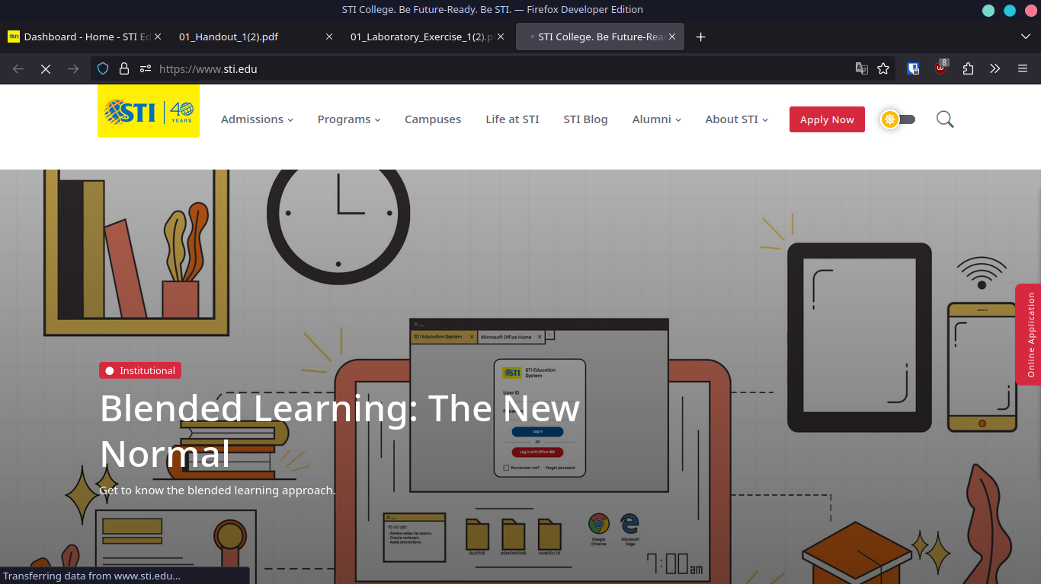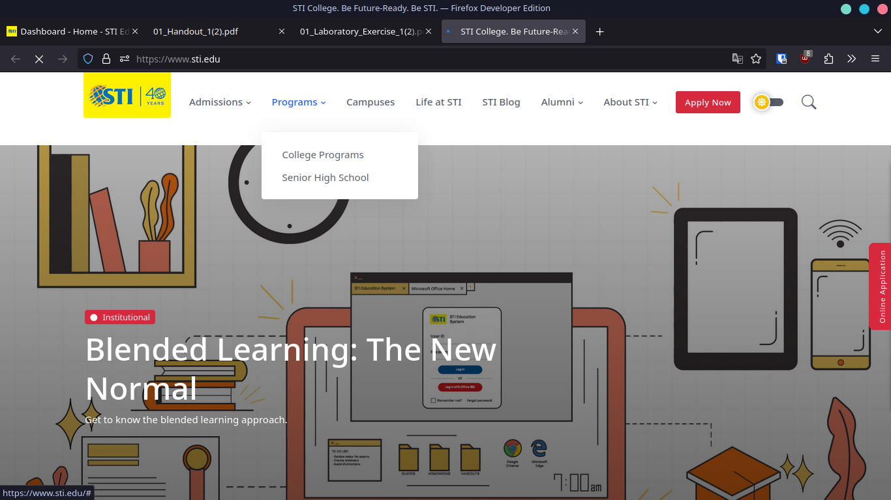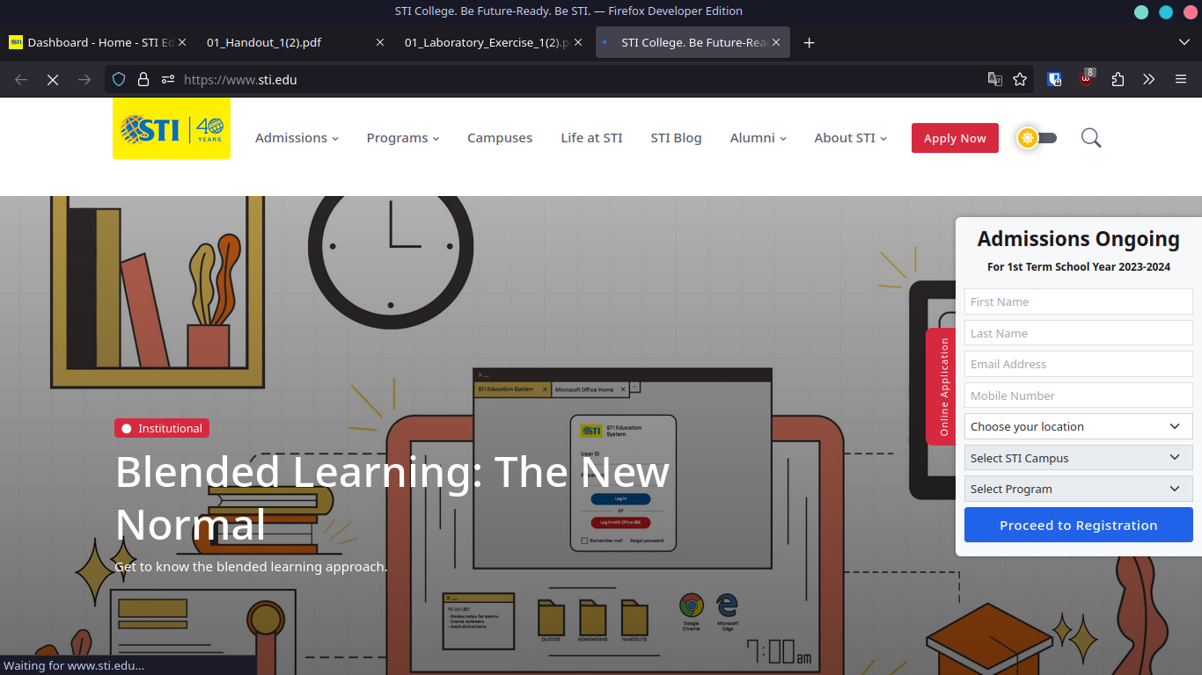

**Principle that the STI Website needs improvement on:**

So basically, I picked “Natural Interaction and Interface” as when I was doing an Online Application, it just kept on reloading and reloading, leaving the user confused. The website didn’t say anything, nothing popped up, nothing showed up to inform the user what had happen. Nothing showed/popped up to tell the user what had gone wrong and what the user needs to do to make something right. The user did something wrong or is confused, it just went ahead and reloaded the page and didn’t do anything. Didn’t explain anything, just reloaded the page and makes the user figure the problem out for themselves.

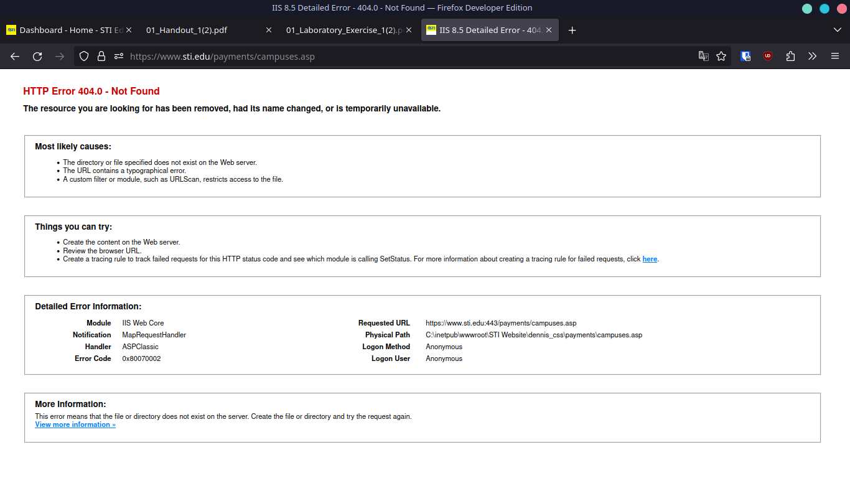

**Why is it important?**

So basically, just to make their lives easier, we just have to make the UI user friendly. Why? Just to make more users able to use your website, simple as that. Another thing, make the UI simple and informative instead of cluttered with useless and confusing stuff. Name every crevices of your website with simple to understand words and have enough information for the user to understand what this and that is. Just having a simple, nice, and organized website is less frustrating to the developers, designers, and the users...